Creating a new build job in Jenkins with Git
- On the Jenkins dashboard, click on Manage Jenkins and select Manage Plugins. Click on the Available tab and write github plugin in the search box.
- Click the checkbox and click on the button, Download now and install after restart.
- Restart Jenkins.
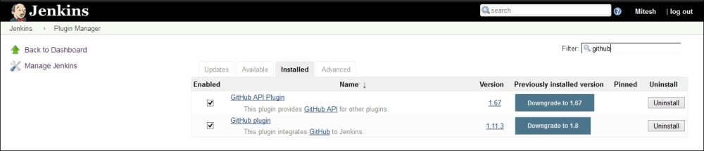
- Create a new Freestyle project. Provide Item name and click on OK.
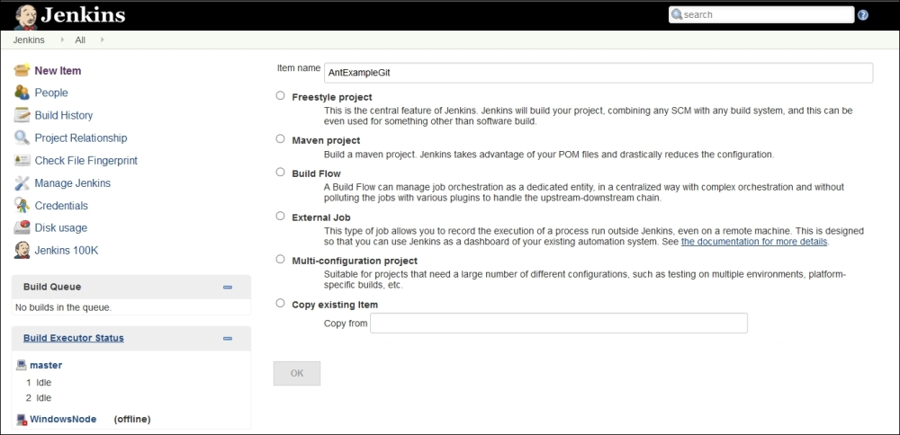
- Configure Git in the Source Code Management section.
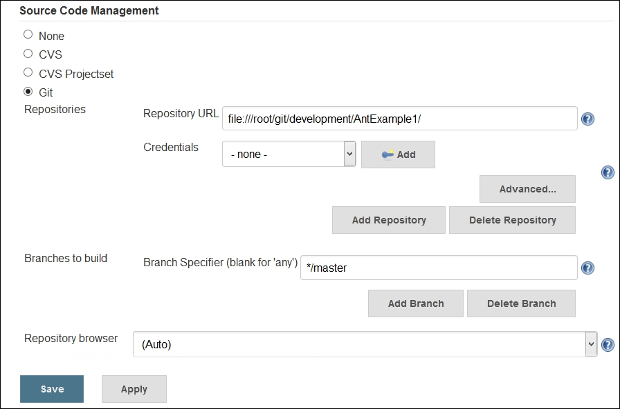
- Add the Invoke Ant build step by clicking on Add build step.
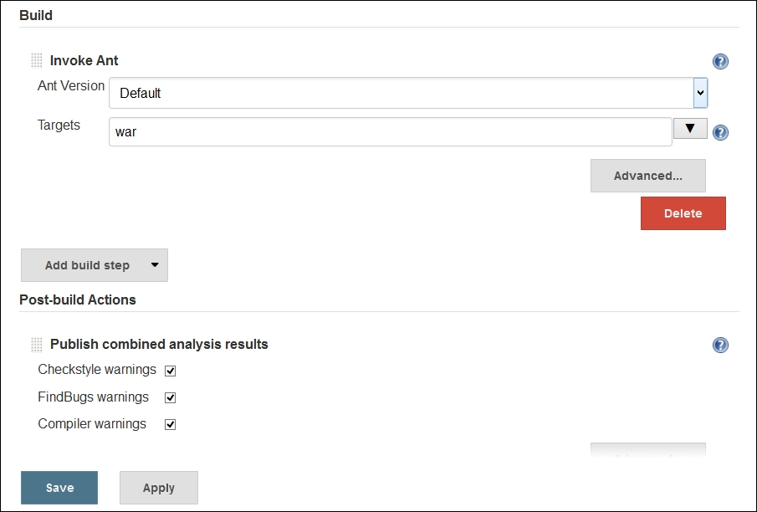
- Execute the build.
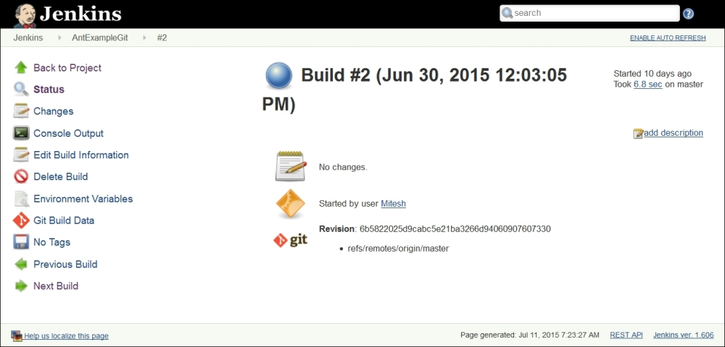
- Click on Console Output to see the progress of the build.
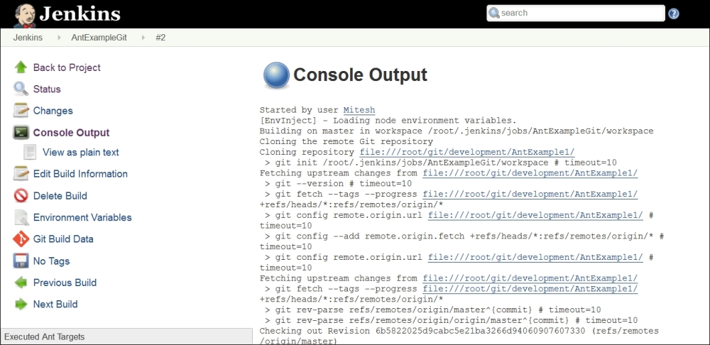
- Once the build has succeeded, verify Workspace in the build job.
